GRAMMAR: This is the last thing you learnt in the grammar section: Present Simple Passive
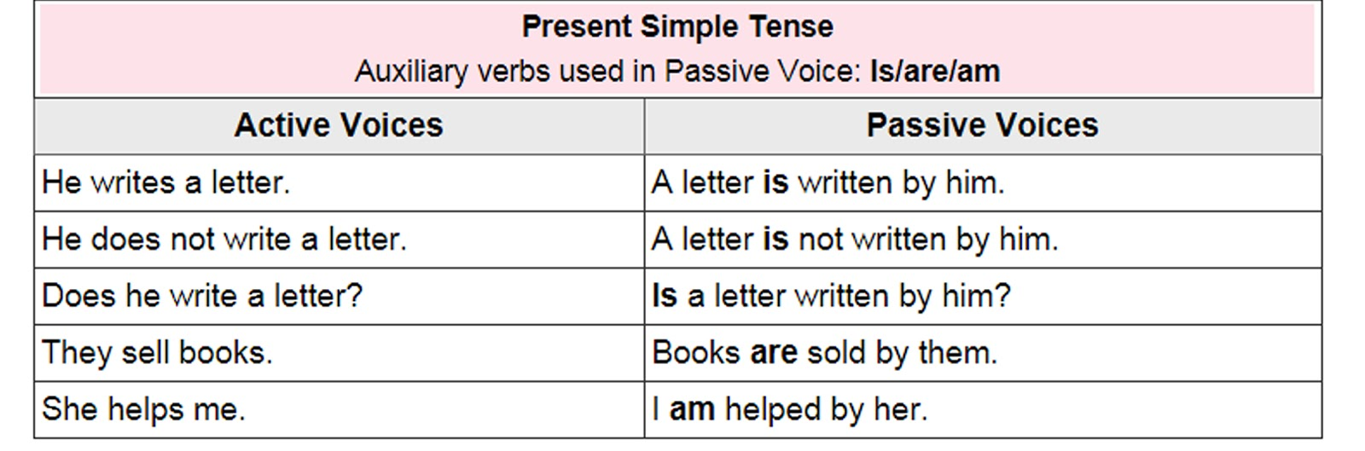
So if in the Present Simple, the passive is: am / is / are + past participle, what do you think we are going to use for the Past Simple Passive? Yes!!!: the past of to be + past participle:
This is the new grammar item for today: the Past Simple Passive:
was / were + past participle
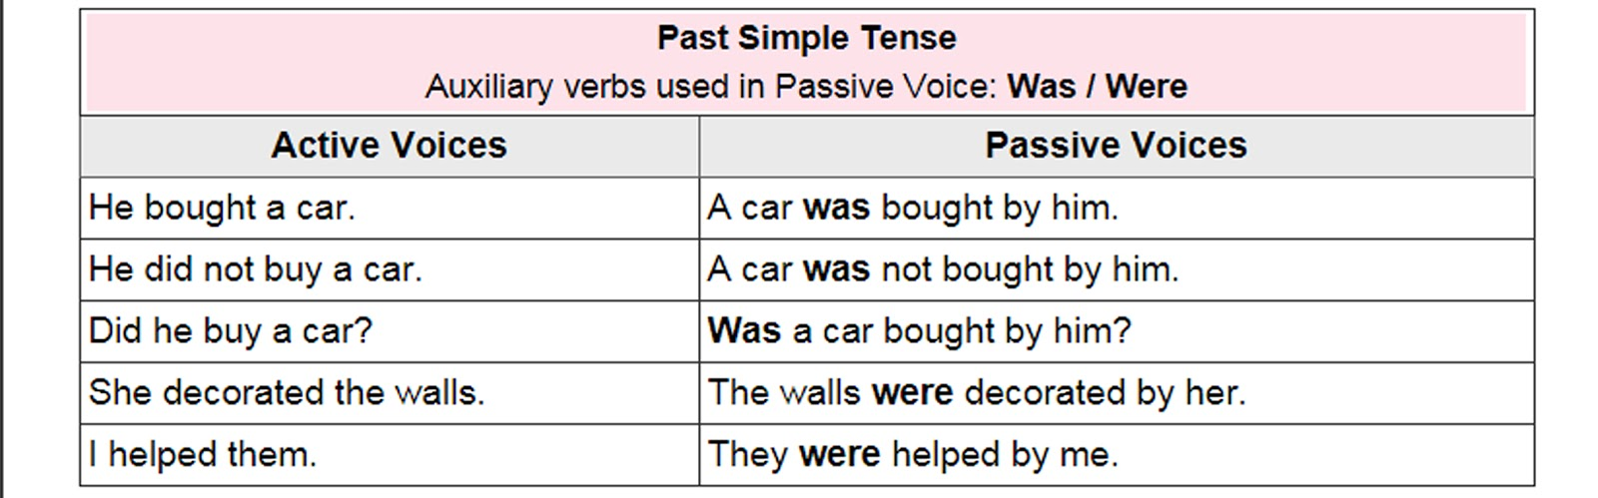Here is an example, so that you can see the difference between the Present and the Past Passive:
Present: Susan writes a letter A letter is written by Susan
Past: Susan wrote a letter A letter was written by Susan
I want to check if you understand the Passive, so do ex.8 pg 113 SB, and send it to me ASAP (As Soon As Possible), so that I can verify if you did it right or wrong.
Then after checking that you understand this new grammatical structure, you have to do these exercises: Ex.6 and 11 pg 113 SB (you can do them on the SB, using a pencil) and pg 75 WB.
Don´t send them, I will give you the keys (right answers) at the end of May (Friday 29th May).

Advance your language Section
Do all the ex. pg.115 SB (Don´t send them, I will give you the keys)
Vocabulary: Life events
If you want to talk about a person´s life, you need to know the events related to his/her life:
He/she was born in… ; He/she died…; He/she studied at…; He/she moved to…; He/she got a job as a…; He/she became a…; He/she met someone and fell in love; He/she got married/got divorced ; He/she had a child/two children…
You are going to need this vocab to do the writing Unit 9 (though the writing is voluntary)

I will do Advance your language pg.116 SB for you. Simply read it and pay attention to these collocations (with get and have): get ill (ponerse enfermo); have an operation (operarse); have a boyfriend (you don´t need me to translate this!!!); get angry (enfadarse); get hungry (sentirse hambriento); have an opinion (tener una opinión)

Speaking: Do ex.7 pg.117 SB on the book, using a pencil.
ex.7 pg.80 WB (Don´t send them, I will give you the keys)

Check your Progress Do ex.1-2-3-4-5 pg.79 WB (Don´t send them, I will give you the keys)

Writing pg 118 This writing is not compulsary; I mean: do it and sent it to me voluntarily. You simply have to write a short biography (a person´s life) about someone famous. It is easier if you choose someone who is dead, you will find a lot of information about him/her. Use the model you have on this pg.118. Ex.4 can also help you write the biography, simply answering those questions about the person.
Tip: don´t forget to use the Connectors of Sequence : first, then, next, after that, finally.

Summary: Send me ex. 8 pg 113 SB and the writing ( this one is voluntary)
I will send the keys of all the other exercises at the end of May (Friday 29th May).
Take good care of yourselves!!!!
Montse.

